**DATABASE MANAGEMENT SYSTEM**

**MINGGU 5 – DATA MANIPULATION LANGUAGE(DML)**

NAMA : ISEP LUTPI NUR

NPM : 2113191079

NO ABSEN : 12

KELAS : A2

# **Exercise 1: Inserting Rows in Tables**

1. **Insert rows into the tables created for the Academic Database based on the following tables:**

### **INSERTING ROWS IN THE AD_ACADEMIC_SESSIONS**

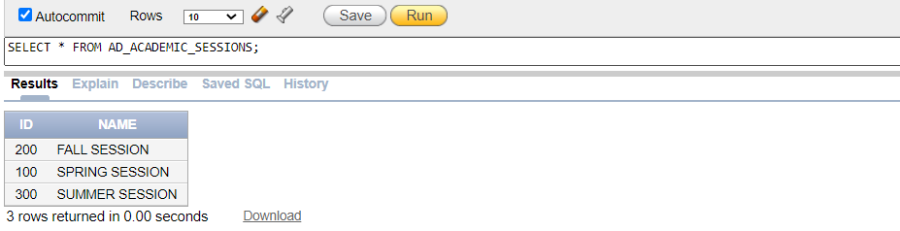

### **INSERTING ROWS IN THE AD_DEPARTMENTS**

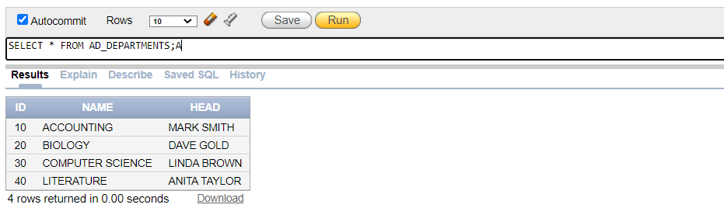

### **INSERTING ROWS IN THE AD_PARENT_INFORMATION**

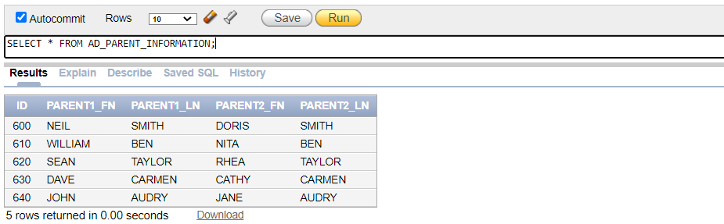

### **INSERTING ROWS IN THE AD_STUDENTS**

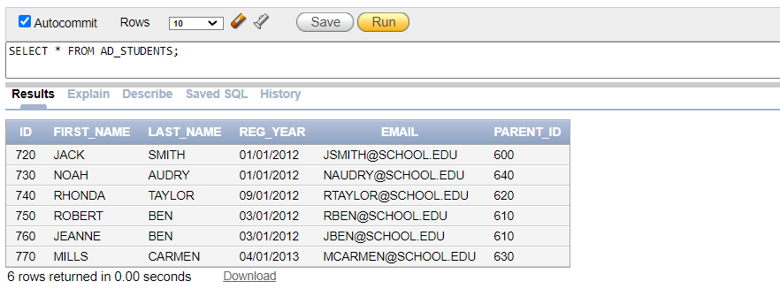

### **INSERTING ROWS IN THE AD_COURSES**

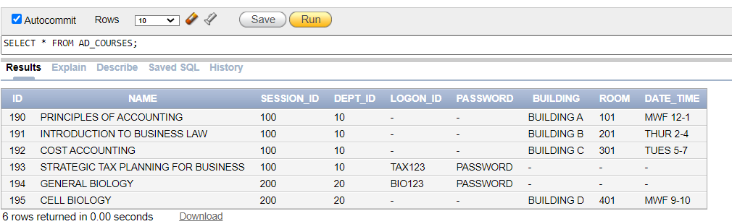

### **INSERTING ROWS IN THE AD_FACULTY**

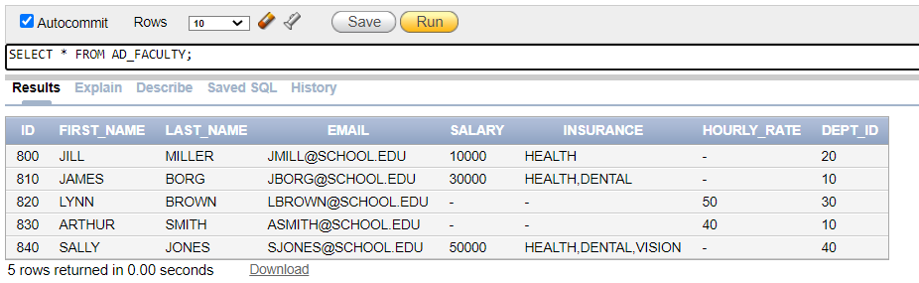

### **INSERTING ROWS IN THE AD_EXAM_TYPES**

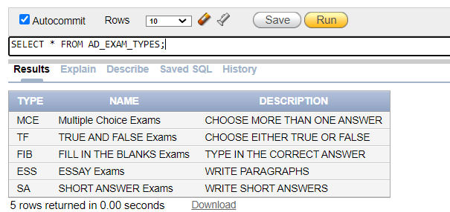

### **INSERTING ROWS IN THE AD_EXAMS**

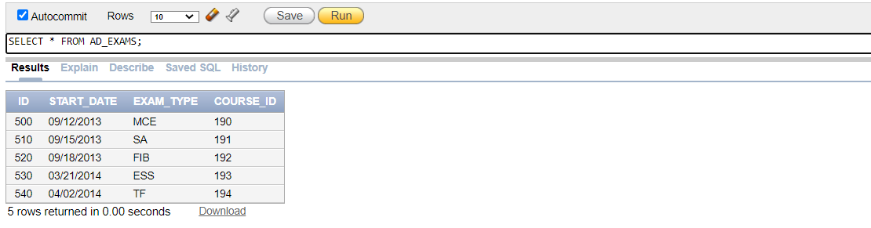

### **INSERTING ROWS IN THE AD_EXAM_RESULTS**

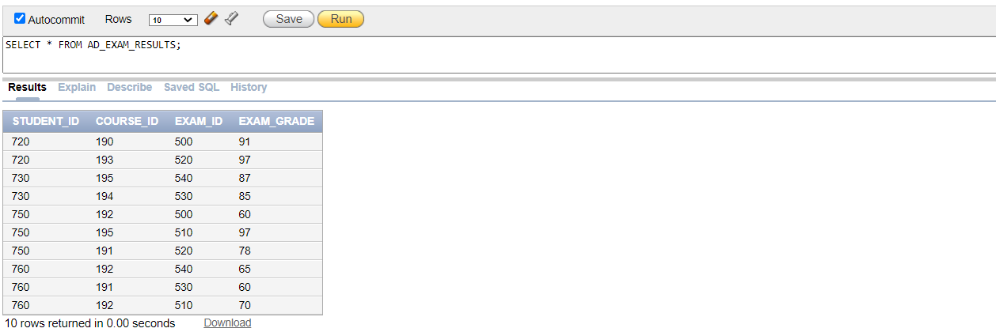

### **INSERTING ROWS IN THE AD_STUDENT_ATTENDANCE**

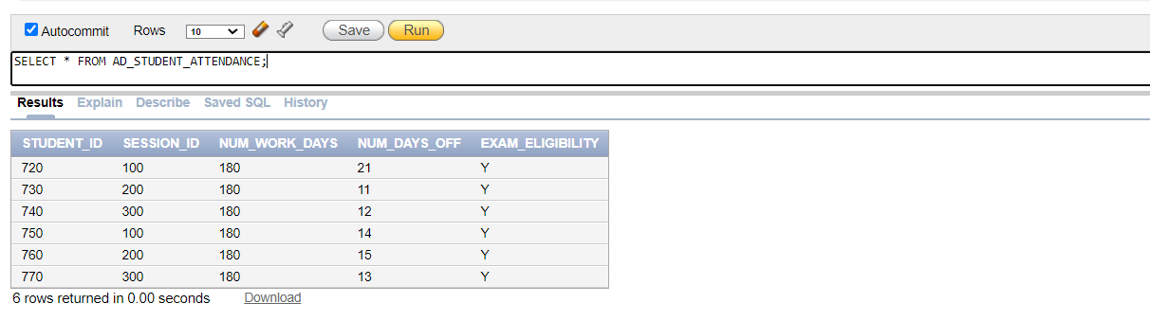

### **INSERTING ROWS IN THE AD_STUDENT_COURSE_DETAILS**

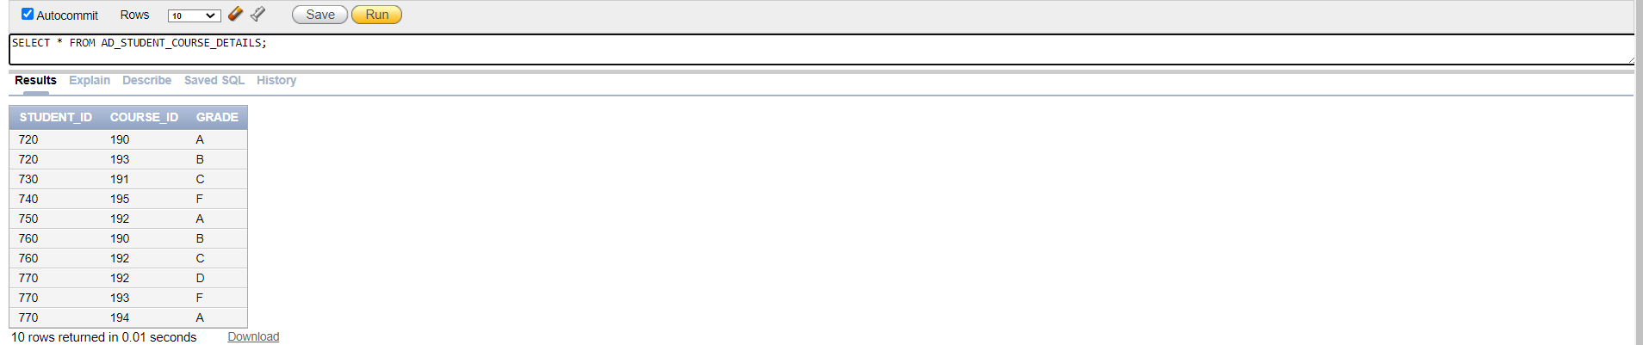

### **INSERTING ROWS IN THE AD_FACULTY_COURSE_DETAILS**

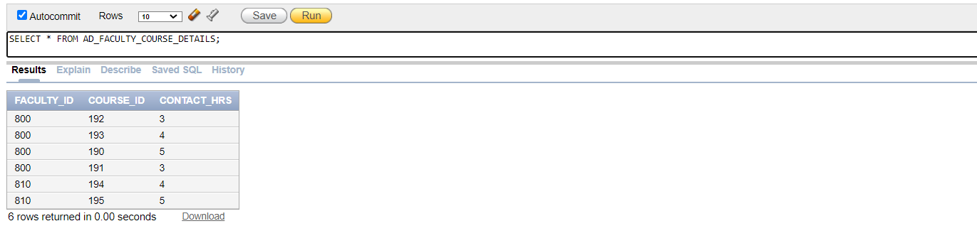

### **INSERTING ROWS IN THE AD_FACULTY_LOGIN_DETAILS**

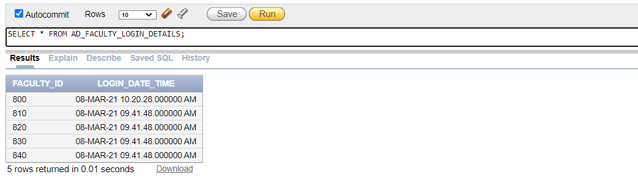

# **Exercise 2: Updating Rows in the Tables**

1. **Alter the AD_FACULTY_LOGIN_DETAILS table to add a field called DETAILS make it a VARCHAR2(50) character field – it can**

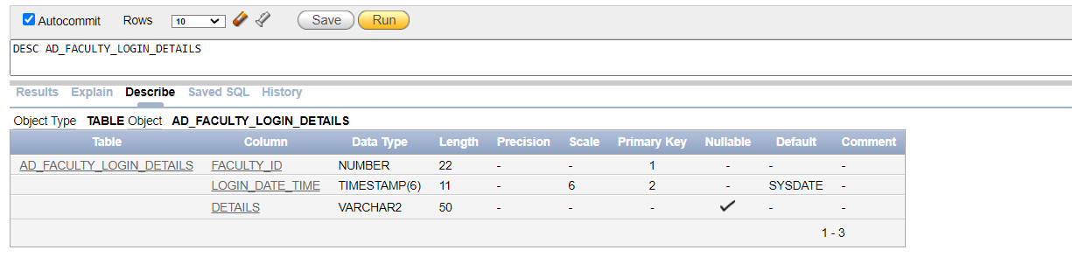

1. **Update at least 2 records in the DETAILS column in the faculty login details table**

